|  |  |
| --- | --- |
| Document Title | Specification of LCD Driver |
| **Document Owner** | Ahmed Ramadan, Felopater Nagy |
| **Document Responsibility** | Ahmed Ramadan, Felopater Nagy |
| **Document Identification No** | 0x02 |
| **Document Version** | 1.0.0 |
| **Document Status** |  |
| **Revision** |  |

|  |  |  |  |
| --- | --- | --- | --- |
|  | **Document Change History** | | |
| **Date** | **Version** | **Changed by** | **Change Description** |
| 16.04.2017 | 1.0.0 |  | Initial Release |

**Disclaimer**

This specification and the material contained in it is for the purpose of information only. The companies that have contributed to it shall not be liable for any use of the specification.

The material contained in this specification is protected by copyright and other types of Intellectual Property Rights. The commercial exploitation of the material contained in this specification requires a license to such Intellectual Property Rights.

This specification may be utilized or reproduced without any modification, in any form or by any means, for informational purposes only.

For any other purpose, no part of the specification may be utilized or reproduced, in any form or by any means, without permission in writing from the publisher.

**Table of Contents**

1 Introduction and functional overview 5

1.1 Objective 5

1.2 Context Diagram 5

1.3 Acronyms and abbreviations 5

2 External interfaces 6

2.1 Std_Types.h 6

2.1.1 Types 6

2.1.2 Interfaces 6

2.1.3 Constants 6

2.1.4 Variables 6

2.2 DIO.h 6

2.2.1 Types 6

2.2.2 Interfaces 6

2.2.3 Constants 6

2.2.4 Variables 6

3 Static Design 7

3.1 File structure 7

3.1.1 Used Files 7

3.1.2 File inclusion 7

3.2 Types 7

3.2.1 Imported types 7

3.2.2 Types Definitions 8

3.2.2.1 LCD configuration 8

3.2.2.2 LCD cursor mode 8

3.3 Symbol Definition 8

3.4 Function definitions 9

3.4.1 LCD_init 9

3.4.2 LCD_Write 9

3.5 Call-back notifications 10

3.6 Scheduled functions 10

3.6.1 LCD_Task 10

4 Dynamic Design 11

4.1 Mode Management 11

4.1.1 Modes of operation of the LCD 11

4.1.2 “Sending data to the LCD “state machine 12

4.2 Sequence Diagram 13

5 Shared Resources 13

6 Configuration specification 14

6.1 Containers and configuration parameters 14

6.1.1 Variants 14

6.1.2 Parameters 14

6.1.2.1 LCD_cfg_t 14

7 Configuration Constraints 15

8 Integration Constraints 15

# Introduction and functional overview

## Objective

This module is used to control the LCD and send the data to the LCD to display them on the LCD screen. The function and configurations described in this document are used to make the process of writing on the screen abstracted from the hardware.

## Context Diagram

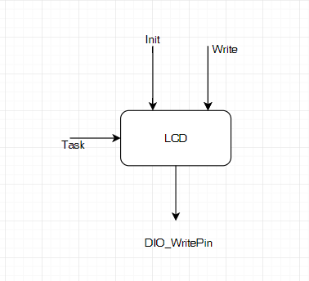

## Acronyms and abbreviations

Acronyms and abbreviations that have a local scope.

|  |  |
| --- | --- |
| ***Abbreviation / Acronym:*** | ***Description:*** |
| LCD | Liquid Crystal Display |
| DIO | Digital input output |
|  |  |

# External interfaces

## Std_Types.h

### Types

|  |  |
| --- | --- |
| Type | ***Description*** |
| u8 | Unsigned Character |
| u16 | Unsigned short integer |
| u32 | Unsigned long integer |
| Bool | Boolean type |

### Interfaces

None

### Constants

None

### Variables

None

## DIO.h

### Types

|  |  |
| --- | --- |
| Type | ***Description*** |
| DIO_pin_Name_t | Enum has the names of the pins used in the DIO |

### Interfaces

|  |  |
| --- | --- |
| Function | ***Description*** |
| DIO_writePin | This function is used to write on a specific pin |

### Constants

None

### Variables

None

# Static Design

## File structure

### Used Files

|  |  |
| --- | --- |
| ***File*** | ***Description*** |
| LCD.h | This file contains the prototypes of the functions used in the module. |
| LCD.c | This file contains the implementation of the functions used in the module. |
| LCD_cfg.h | This file contains the configuration parameters of the module and the configurations type LCD_cfg_t. |
| LCD_cfg.c | This file contains instances of the configuration types and constants used in the module. |

### File inclusion

## Types

### Imported types

|  |  |
| --- | --- |
| ***Module*** | ***Imported Type*** |
| Std_Types.h | u8 |
| u16 |
| u32 |
| bool |
| DIO.h | DIO_pin_Name_t |

### Types Definitions

#### LCD configuration

|  |  |  |  |
| --- | --- | --- | --- |
| ***Name:*** | LCD_cfg_t | | |
| ***Type:*** | Structure | | |
| ***Elements:*** | DIO_pin_Name_t[] | LCD_data_pins | This array that have the DIO pins connected to the LCD |
| DIO_pin_Name_t | LCD_RSPin | This pin is connected to the RS pin In the LCD |
| DIO_pin_Name_t | LCD_RWPin | This pin is connected to the read/write pin on the LCD |
| DIO_pin_Name_t | LCD_EPin | This pin is connected to the Enable pin on the LCD |
| LCD_Cursor_Mode | LCD_Cursor_mode | This mode is the mode of the cursor (displayed/not displayed) |
| ***Description:*** | The configuration structure has the pin mapping of the LCD pins (data pins, RS, R/W, E) and the mode of the cursor of the LCD | | |

#### LCD cursor mode

|  |  |  |  |
| --- | --- | --- | --- |
| ***Name:*** | LCD_Cursor_Mode_t | | |
| ***Type:*** | Enum | | |
| ***Range:*** | LCD_Cursor_off | 0 | Mode of the cursor not displayed |
| LCD_Cursor_on_with_Blinking | 1 | This pin is connected to the RS pin in the LCD |
| LCD_Cursor_on_without_Blinking | 2 | This pin is connected to the read/write pin on the LCD |
| ***Description:*** | Cursor modes which user can use to describe the cursor behavior. | | |

## Symbol Definition

|  |  |
| --- | --- |
| ***Name:*** |  |
| ***Type:*** |  |
| ***Value:*** |  |
| ***Description:*** |  |

## Function definitions

This is a list of functions provided for upper layer modules.

### LCD_init

|  |  |  |
| --- | --- | --- |
| ***Service name:*** | LCD_Init | |
| ***Syntax:*** | void LCD_Init (  void  ); | |
| ***Service ID[hex]:*** | 0x01 | |
| ***Sync/Async:*** | Synchronous | |
| ***Reentrancy:*** |  | |
| ***Parameters (in):*** | None |  |
| ***Parameters (in/out):*** | None | |
| ***Parameters (out):*** | None | |
| ***Return value:*** | void |  |
| ***Description:*** | This is the initializing the LCD module. | |

### LCD_Write

|  |  |  |
| --- | --- | --- |
| ***Service name:*** | LCD_Write | |
| ***Syntax:*** | bool LCD_Write (  u8 *Text,  u8 Xloc,  u8 Yloc  ); | |
| ***Service ID[hex]:*** | 0x02 | |
| ***Sync/Async:*** | Asynchronous | |
| ***Reentrancy:*** |  | |
| ***Parameters (in):*** | Text | Pointer to the array contains the value to be written on the LCD |
| Xloc | Has the value of the column- of the LCD- which the first character of Text is Written on. |
| Yloc | Has the value of the row - of the LCD- which the first character of Text is Written on. |
| ***Parameters (in/out):*** | None | |
| ***Parameters (out):*** | None | |
| ***Return value:*** | bool | Either has Std_True or Std_False |
| ***Description:*** | Used to send array to be written on the screen on the column with number Xloc and the row with number Yloc. | |

## Call-back notifications

This chapter lists all functions provided by the LCD module to lower layers.

The LCD module does not provide any callback notifications.

## Scheduled functions

This chapter lists all functions called directly by the Basic Software Module Scheduler.

### LCD_Task

|  |  |  |
| --- | --- | --- |
| ***Service name:*** | LCD_Task | |
| ***Syntax:*** | Void LCD_Task (  Void  ); | |
| ***Service ID[hex]:*** | 0x03 | |
| ***Sync/Async:*** | Synchronous | |
| ***Reentrancy:*** |  | |
| ***Parameters (in):*** | None | |
| ***Parameters (in/out):*** | None | |
| ***Parameters (out):*** | None | |
| ***Return value:*** | void |  |
| ***Description:*** | Used to Manage the modes and states -mentioned in chapter 4- of the LCD module. | |

# Dynamic Design

## Mode Management

### Modes of operation of the LCD

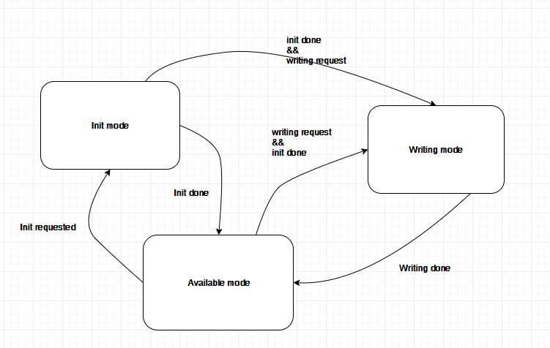

### “Sending data to the LCD “state machine

This state machine describes the change between states of writing on the data pins and disabling writing.

## Sequence Diagram

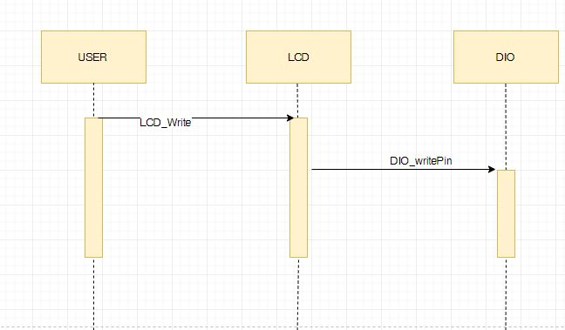

# Shared Resources

|  |  |
| --- | --- |
| variable | ***Description*** |
| LCD_Mode | This is the mode of the operation of LCD |
| LCD_Phase | This is the Phase of the LCD in sending and Init modes |
| Data | Pointer to the data to be sent on the data pins |
| Xlocation | Variable indicates the number of the column of the LCD on which the first character is written |
| Ylocation | Variable indicates the number of the row of the LCD on which the first character is written |

# Configuration specification

This chapter defines configuration parameters and their clustering into containers.

## Containers and configuration parameters

The following chapters summarize all configuration parameters.

### Variants

Configuration variants describe sets of configuration parameters:

* VARIANT-PRE-COMPILE (PC)

Only parameters with "Pre-compile time" configuration are allowed in this variant.

* VARIANT-LINK-TIME (LT)

Only parameters with "Pre-compile time" and "Link time" are allowed in this variant.

* VARIANT-POST-BUILD (PB)

Parameters with "Pre-compile time", "Link time" and "Post-build time" are allowed in this variant.

Parameters

### 

### Parameters

#### LCD_cfg_t

|  |  |  |  |
| --- | --- | --- | --- |
| ***Name*** | LCD_cfg_t | | |
| ***Description*** | The configuration structure of the LCD | | |
| ***Multiplicity*** | 1 | | |
| ***Type*** | structure | | |
| ***Default value*** | -- | | |
| ***Configuration Class*** | ***Pre-compile time*** | | |
| ***Configuration Class***  ***Scope / Dependency*** | ***Link time*** | X | All Variants |
| ***Post-build time*** | -- |  |
| scope: local | -- |  |
|  |  | | |

# Configuration Constraints

None

# Integration Constraints

None